Cloud Architecture DRIVE SPHERE

by Jaspreet Singh

Table of Contents

INTRODUCTION

MISSION

OBJECTIVES

STRATEGIC GOALS

Cloud Architecture

Data Sources

Data Pipeline Design

Process of Creating a Data Pipeline

Pipeline Failure Strategy

Conclusion

Introduction

DriveSphere is at the forefront of AI-powered generative automotive technology, transforming product development through cutting-edge data analytics. By analyzing user behavior, competitor trends, and social sentiment, we continuously enhance vehicle features using real-time feedback and predictive insights. Our AI solutions streamline design, automate services, and deliver personalized customer experiences—driving the evolution of intelligent mobility.

MISSION

• **Drive Customer Engagement and Accelerate Sales**  
Our objective is to strengthen customer connections and boost vehicle sales through data-driven marketing initiatives. By optimizing interactions across digital platforms and in-person experiences, and leveraging AI-powered predictive analytics, we deliver highly targeted and impactful campaigns that resonate with consumers.

• **Build a Sustainable and Forward-Thinking Automotive Ecosystem**  
We are committed to creating an environmentally responsible automotive landscape that integrates breakthrough innovations with sustainable practices. Our vision is to lead the transition toward a cleaner, smarter, and more connected future of mobility.

OBJECTIVES

**1. Develop a Data-Driven Vehicle Optimization System**

* Create a scalable data infrastructure to aggregate, clean, and process sales data from diverse sources.
* Utilize both historical trends and real-time insights to identify top-performing vehicle models and anticipate emerging market demands.
* Provide production and supply chain teams with actionable intelligence to enhance manufacturing efficiency and inventory management.

**2. Implement AI-Powered Customer Intelligence & Marketing Solutions**

* Design a robust data architecture incorporating Natural Language Processing (NLP) and machine learning to analyze customer sentiment across digital channels.
* Build intelligent recommendation engines that power personalized marketing strategies based on individual customer preferences and behavior.
* Automate data pipelines to continuously refine engagement tactics and improve campaign performance.

**3. Elevate Dealer Network Performance through Predictive Analytics**

* Develop a centralized data warehouse to unify and track critical dealership performance metrics.
* Leverage predictive analytics to deliver insights that support accurate sales forecasting and operational optimization.
* Implement real-time dashboards and reporting tools to enable agile decision-making and enhance dealer-level strategy execution.

**Build a Data-Driven Vehicle Optimization Platform**

* Develop a robust and scalable infrastructure to collect, cleanse, and process vehicle sales data from multiple sources.
* Integrate historical data with real-time analytics to pinpoint high-performing models and detect shifting market trends.
* Equip production and supply chain teams with actionable insights to streamline manufacturing processes and optimize inventory management.

**2. Deploy AI-Driven Customer Intelligence and Marketing Framework**

* Establish an advanced data architecture powered by Natural Language Processing (NLP) and machine learning to decode customer sentiment across various channels.
* Create AI-based recommendation systems to deliver hyper-personalized marketing campaigns tailored to customer behaviors and preferences.
* Automate data workflows to ensure ongoing enhancement of customer engagement strategies and campaign effectiveness.

**3. Optimize Dealer Network Performance Using Predictive Analytics**

* Centralize dealer data into a unified warehouse for comprehensive performance tracking and analysis.
* Apply predictive models to generate accurate sales forecasts and identify opportunities for operational improvements.
* Introduce real-time dashboards and analytics tools that empower dealerships with dynamic, data-backed decision-making capabilities.

**Strategic Goals**

* **Enhance Customer Engagement**  
  Create personalized, interactive experiences that deepen customer relationships and strengthen brand loyalty.
* **Optimize Marketing Performance**  
  Leverage AI and data-driven insights to develop targeted, impactful marketing campaigns across digital and traditional channels.
* **Increase Sales Effectiveness**  
  Streamline the sales cycle and align product offerings with market demand to drive consistent revenue growth.
* **Harness Customer Insights**  
  Analyze behavioral patterns and sentiment data to gain a deeper understanding of customer needs, preferences, and expectations.
* **Boost Operational Efficiency**  
  Automate key workflows and optimize resource utilization to reduce operational costs and enhance productivity.
* **Enable Data-Driven Decision Making**  
  Embed real-time analytics into core business functions to support faster, more informed, and agile decision-making.
* **Strengthen Customer Retention**  
  Implement loyalty initiatives and proactive support strategies to improve satisfaction and maximize customer lifetime value.

Cloud Architecture: Stage 1

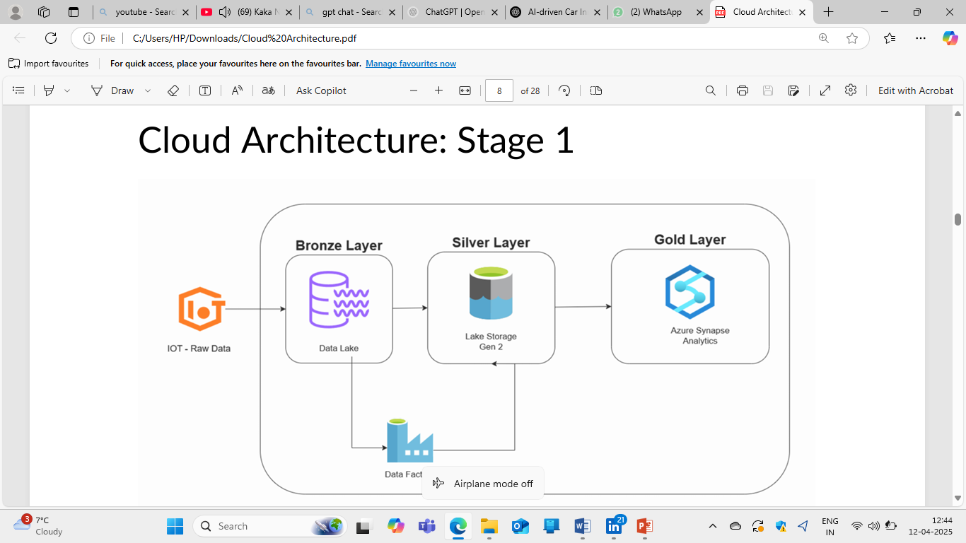

Final stage of architecture

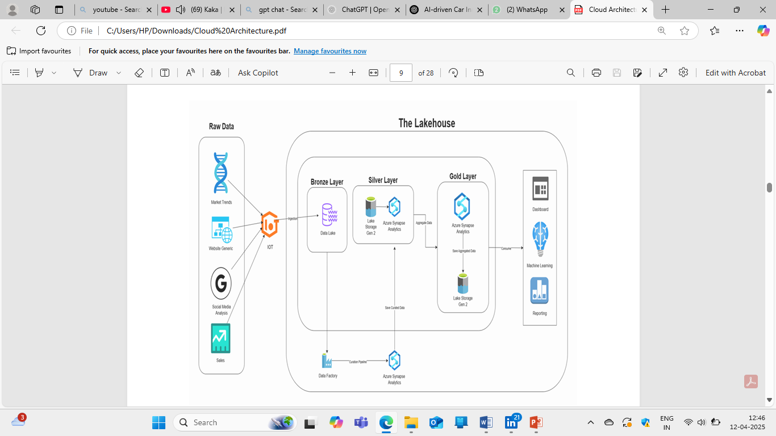

**Data Sources**

**Market Trends**

• Description: External datasets offering macro-level insights including market analytics, economic indicators, and industry benchmarks.

• Source Type: Market intelligence tools, web analytics platforms (e.g., Google Analytics, Adobe Analytics)

• Access Method: Real-time API access or scheduled exports (JSON, CSV)

**Website Analytics (Generic)**

• Description: Captures user interaction metrics such as traffic volume, bounce rates, session durations, and click through behaviour.

• Source Type: Web server logs, Tag Management Systems (e.g., Google Tag Manager), Cloud Storage (e.g., Azure Blob, AWS S3)

• Access Method: Downloadable via HTTP/SFTP or accessed through Cloud SDKs

**Social Media Analysis**

• Description: Extracts data from platforms like Twitter, LinkedIn, and Instagram for sentiment analysis, engagement metrics, and influencer tracking.

• Source Type: Native social media APIs, third-party sentiment and influencer analytics platforms

• Access Method: Streaming services or REST APIs

**Sales Data**

• Description: Transaction-level data from point-of-sale systems, CRM tools, and ecommerce platforms for sales tracking and trend analysis.

• Source Type: Internal CRM/ERP systems (e.g., Salesforce, SAP), customer feedback platforms

• Access Method: SQL database queries, REST APIs, or direct database exports

**Data Pipeline Design**

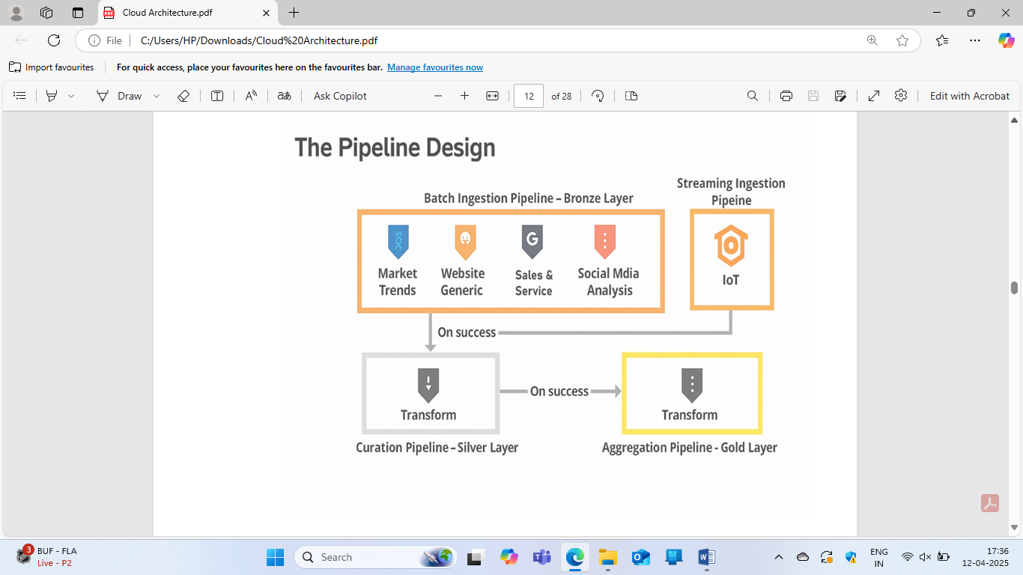

Process of Creating a Data Pipeline

Ingestion Layer – IoT-Styled Data Intake

**Purpose:**

The Ingestion Layer acts as the first entry point of the data pipeline. It’s designed to handle diverse data sources and ensure reliable delivery to the downstream storage system.

Key Features:

• **Data Collection:**

Gathers raw data from various inputs including IoT devices, CRM systems, APIs, social media streams, and web platforms.

• **Batch & Streaming Support:**

* Batch: Periodic file uploads or database extracts
* Streaming: Real-time event data from sensors or APIs using tools like Apache Kafka, AWS Kinesis, or MQTT

• **Initial Processing:**

* Performs basic validation, formatting, and routing logic.
* Converts raw inputs into standardized formats (JSON, Parquet, Avro).

• Reliability: Implements checkpointing and retry mechanisms to prevent data loss or duplication.

• Flow Direction: Successfully ingested data is pushed to the Bronze Layer for raw storage.

**3) Silver Layer – Curation Pipeline** : Data stored in Data Factory is processed and cleaned, filtered, joined, and transformed.

* Azure Synapse Analytics performs transformation tasks.
* The process starts by looking at sample data to check its quality.
* First, they visually check the data from different sources.
* Sometimes, they need to use simple programs to find and fix problems like:
  + Data that doesn't follow a standard format.
  + Incorrect or repeated information.
  + Data that's not secure or consistent.

**Gold Layer – Aggregated, Business-Ready Data**

* Aggregation is a technique that's used to identify patterns over a collection of observations using a set of variables.
* Before verifying the aggregated data, we should focus on how our end users will be able to consume data for dashboarding, ML, and Al purposes.
* **Azure Synapse Analytics** reprocesses curated data to produce **aggregated insights** :

Ex,

* + Monthly summaries
  + Key performance indicators (KPIs)
  + Trend lines and forecasts
* These are stored back in **Lake Storage Gen 2** as finalized datasets.

**Consumption Layer : business value is extracted from the data**

* + **Dashboard : Tools like Power BI or Tableau use this layer to create real-time dashboards.**
  + **Machine Learning : Data scientists consume gold layer data for model training, scoring, and inference.**
  + **Reporting : Automated reports, regulatory filings, or operational summaries are generated from here.**
* **Data in this stage is trustworthy, high quality, and optimized for analytics.**

**Pipeline Failure Strategy – Ensuring Robustness and Reliability**

A pipeline failure strategy is essential to ensure data processing pipelines are reliable, resilient, and capable of recovering gracefully when issues occur. Given the complexity of modern data systems, failures can happen at various stages in the pipeline—whether during data ingestion, processing, or storage. A well-defined strategy minimizes downtime and ensures that business operations can continue smoothly even in the face of technical failures. Here’s a comprehensive failure strategy to ensure that your data pipeline can handle interruptions effectively

* 1. **Monitoring and Alerts**

Key Components:

• Real-time Monitoring: Continuously monitor every stage of the pipeline (e.g., ingestion, processing, storage). Tools like Prometheus, Grafana, or Datadog can track key metrics (latency, error rates, resource consumption)

• Automated Alerts: Set up automated alerts for critical failures like service downtimes, data quality issues, or performance bottlenecks. Alerts can be sent via email, Slack, or other collaboration tools.

• Health Checks: Implement periodic health checks for each component of the pipeline to ensure systems are running as expected (e.g., checking if APIs are responsive, databases are accessible, data is being ingested in the right format).

* 1. **Logging and Audit Trails**

Key Components:

• Centralized Logging: Use a centralized logging system (e.g., ELK Stack - Elasticsearch, Logstash, Kibana, or Splunk) to aggregate logs from different pipeline components.

• Error Logs: Capture detailed error logs at each stage of the pipeline (e.g., ingestion failures, transformation errors, connection issues).

• Audit Trails: Maintain audit trails that track each data transformation and processing step. This helps diagnose failures and understand what went wrong during each pipeline run. •   
 3. **Data Quality Checks**

Key Components:

• Data Validation: Implement data validation checks at every stage of the pipeline (e.g., schema validation, integrity checks, format validation).

• Alerting on Invalid Data: If data does not meet the predefined quality rules (e.g., missing fields, incorrect data formats), trigger alerts or automated actions.

• Automated Data Cleaning: Automate data cleaning or imputation strategies to handle missing values, duplicates, or outliers to prevent failures during downstream processing.

* 1. **Retry and Backoff Mechanism**

Key Components:

• Automatic Retries: For transient failures (e.g., temporary network outages, service unavailability), implement automatic retries for failed operations. Use exponential backoff strategies to avoid overwhelming the system.

• Error Rate Thresholds: Set thresholds for retries—if a failure occurs more than a set number of times, escalate it to a manual review or fail the process altogether.

• Grace Period: Set a grace period for retries (e.g., retry for 15 minutes before escalating or failing the pipeline**).**

**5. Fault Tolerance and Redundancy**

Key Components:

• Redundant Systems: Ensure that critical components of your pipeline (e.g., data storage, processing nodes) are redundant across multiple servers or availability zones to reduce single points of failure.

• Failover Mechanisms: Design the pipeline with failover mechanisms, so when a component fails, another can take over without interrupting the pipeline.

• Distributed Systems: Leverage distributed processing frameworks like Apache Spark, Hadoop, or Kubernetes to ensure that the system remains operational even when individual nodes fail.

**Conclusion**

DriveSphere leverages data, AI, and automation to transform the automotive industry by helping businesses make smarter, data driven decisions. By analysing customer behaviour, market trends, and sales data, DriveSphere enables companies to gain a deeper understanding of their customers and optimize their marketing strategies. This approach allows businesses to create personalized customer experiences, engage more effectively, and build stronger connections with their target audience.

Using advanced AI algorithms, DriveSphere provides real-time insights that empower companies to stay ahead of the competition in a rapidly evolving market. These insights help businesses fine-tune their marketing efforts, increase sales, and drive growth by identifying emerging trends, understanding consumer preferences, and predicting future demands. By continuously monitoring and analysing vast amounts of data, DriveSphere helps companies make informed decisions quickly and efficiently, enabling them to adjust to changing market conditions and customer needs.

DriveSphere's automation tools further streamline operations, reducing manual effort and allowing businesses to focus on strategic tasks. Ultimately, the platform equips automotive businesses with the tools to thrive in an increasingly dynamic environment, improving customer engagement, enhancing marketing performance, and driving overall business success.